PHASE 2: Backend Development & Configuration

Activity 1: Create a Custom Table for Ticket Records
Steps to Create the Custom Table:
- Open All menus → Search for Tables.
- Under System Definition, select Tables.
- Click the New button in the top right corner.
- Label: Incident Workflow.
- Clear the Create module checkbox.
- Click Save.
- Open the Controls section and enable Auto Number.
- Save the form again.

- Save the form and, under Related Links, click Show Form.
- Open Configure from the context menu and select Form Designer.
- Create the required fields in the form.
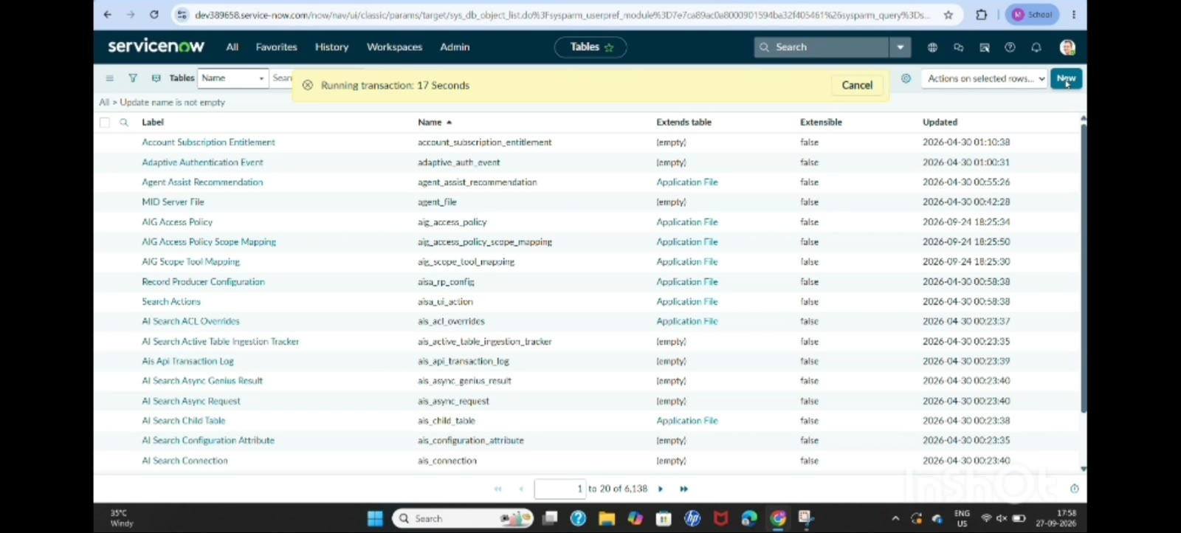
Activity 2: Field Creation and Data Type Configuration
The objective of this activity is to create the required fields in the School IT Ticket table with suitable data types, choices, and dependencies so that ticket information is captured consistently.

Field Label | Type | Reference/Choice
Number | Auto Number | —
Caller | Reference | sys_user
Category | Choice | [Network,Hardware,Access, Performance]
Subcategory | Choice | [Wi-Fi,Projector,Forgot Password,Slow Compter]
Short Description | String | –
Description | String | –
State | Choice | [New,In progress,On hold,Resolved,Closed]
Assigned Group | Reference | sys_user_group
Assigned to | Reference | sys_user

- After Creating Fields with their appropriate Type, then add the Choice from the Form design.
- To all the Choice list Fields.
- They are Category,Subcategory and State.
- Same like that, add Choice to the State field.
- Then Click the save button on the top right corner.
- Open the Form and reload it.

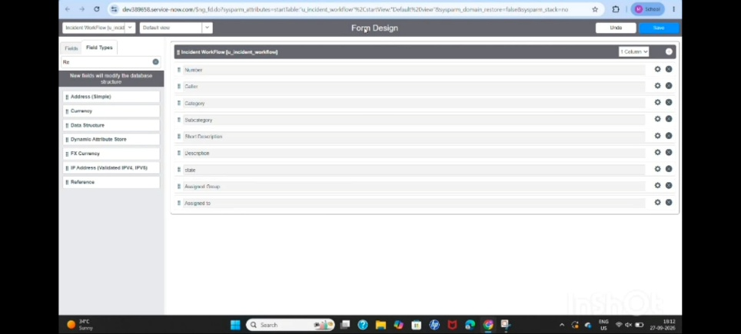
Activity 3: Implement Dependency Between Category and Subcategory
The objective is to establish a dependency relationship between Category and Subcategory so that the available Subcategory choices change according to the selected Category.

Navigation Steps:
- Open the created table form and right click the Subcategory field.
- Select Configure Dictionary.
- Under Related Links, open the Advanced view.
- Locate the Dependent Field section.
- Enable Use dependent field.
- Select Category in the Dependent on field option.
- Then save the Form.

- Now scroll down to the choice section.
- In the choice section, configure the dependent values by assigning the Category choice backend value to each corresponding Subcategory choice.
- Wi Fi → Network.
- Projector → Hardware.
- Forgot password → Access.
- Slow computer → Performance.

- Then save the Form.
- Then it will display each choice to each one separately based on the category subcategory displays.

